Solutions? Activities? Interventions?
….to support the outcomes for children, young people and families struggling to attend well
Focus: those at risk of, or already, persistently or severely absent from school, college or alternative learning setting in Redcar & Cleveland
“…like safeguarding attendance should be everyone’s business.” (RT-MAT Attendance Hub)

EBSA   |     Attendance Hubs  How attendance hubs are tackling soaring absences – September 2023 - Leaders are going beyond the school gates in their push to get children back in the classroom. Solutions…  “Forensic data’ is key … … but schools need to go ‘extra mile.’ You need to build trust with the family and find out what’s going on at home, to strengthen that bridge. Improving attendance takes time.”
Attendance Mentors

1-2-1 mentoring pilot (delivered by Barnardo’s) in Middlesbrough aimed at tackling the factors behind non-attendance (since extended to other areas targeting support for 1,665 persistently absent and severely absent children in total)

Creative solutions linked to children and young people telling their stories their way
Creative Partnership Programme such as the type completed by Blue Cabin with 4-5 care experienced  children / young people.  A small cohort of Blue Cabin  Films and comics created alongside young people have been suggested as solutions |  | Working with specific populations e.g. carers in creative ways  We Care You Care - Help and support for all carers living across the South Tees area | We Care You Care



Pilot projects to build evidence of what works to reduce absence, exclusions and improve attendance

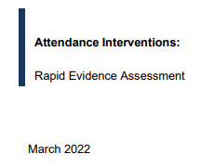  A review of evidence that organised findings around 8 topics. Evidence was weak overall, so investment is being made to learn more >>>>>  - Mentoring  - Parental engagement  - Responsive and targeted approaches  - Teaching of social and emotional skills  - Behaviour interventions  - Meal provision  - Incentives and disincentives  - Extracurricular activities | (March 2022 specification)  We are looking for programmes that focus on enabling 5-18 year olds to attend, positively engage with and remain in school, thereby improving attainment and reducing the likelihood of them becoming involved in violence.  - Anti-bullying programmes  - Classroom Behaviour Management programmes  - Internal Alternative Provision interventions  - Needs-led attendance interventions  - Parent/carer communication interventions  - Social and emotional learning interventions  - Targeted family engagement interventions.
Live Pilots

A safe, positive place to learn: improving attendance and reducing exclusions - Youth Endowment Fund

Grassroots: a programme to improve pupil behaviour (2023/24 –… | EEF (educationendowmentfoundation.org.uk)

BITUP: Updating Parents on Number of School Days Missed… | EEF (educationendowmentfoundation.org.uk) – this is a parent messaging trial - Updating Parents on Number of School Days Missed - working with The Behavioural Insights Team (2022/23)

Solutions linked to health and wellbeing

To understand how to support young people and reduce health inequalities – targeting some of the causes of absence at root cause…
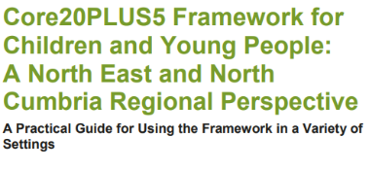


The Network has 10 priorities and system partners that work with children and young people across topics that correlate with school absence – are we linking up to maximum effect?

  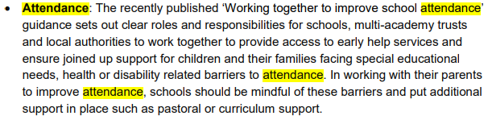 | 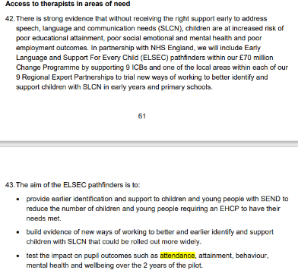  ELSEC Pathfinders with NHS England
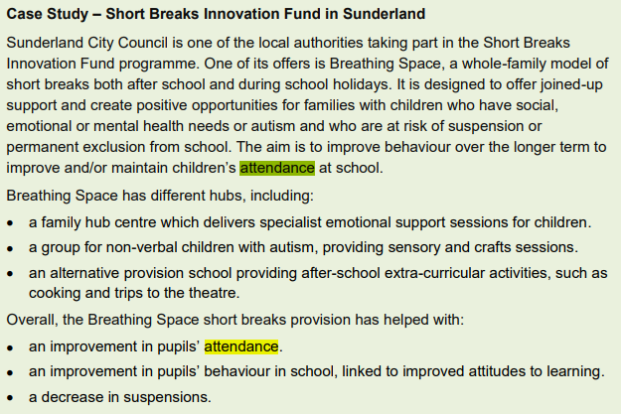
Whole family working to improve and / or maintain children’s attendance at school
Evidence Gap: We need to find out the impact of health on attendance behaviours more generally in order to more confidently put in place interventions that will work for each child and family’s circumstance


LETTER TO LAs: CALL TO SUPPORT STRONG ATTENDANCE FROM THE FIRST DAY OF TERM (July 2023) lists a number of actions and solutions.
new school attendance guidance
LGA conference speech
Toolkit for schools: communicating with families to support attendance

To support a strong return to school in September these ideas were suggested to local authorities:
- ‘…rigorous analysis of absence data to identify the pupils, cohorts and schools that need the most support, ensuring join-up and data-sharing is established with relevant agencies such as children’s social care and SEND, and communicating the area-wide school attendance strategy across the council.’
- ‘Over the summer I urge you to mobilise your wider services and staff who have contact with parents and children to help to communicate the importance of a strong return to school. I believe we have a real opportunity to reset the system, if we can ensure that trusted voices are giving the same messages.’
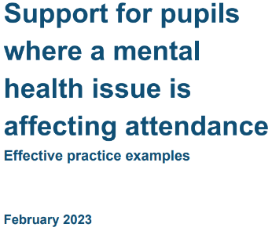
Examples of good practice:
- social workers and early help workers ensuring that that every conversation with a pupil and family involves school attendance and addressing any barriers
- school nurses identifying and working with pupils who are anxious about returning to school
- family hubs giving out information to parents on illness and absence and sharing our attendance guidance for parents
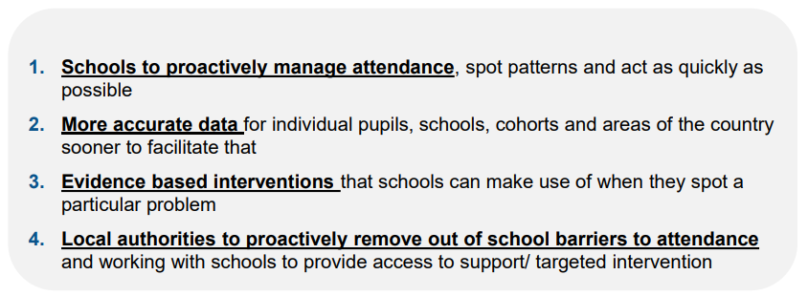
Working Together to Improve School Attendance, DfE Seminar, June 2023 offered these suggestions >>>

DfE have been focused on clear, strong expectations in their guidance for schools, MATs and local authorities; richer and more timely (daily) attendance data collection from schools, leadership via the AAA and pledges to remove barriers by those system partners, building the evidence base (with EEF) including funding to trial Attendance Mentors, and sharing practice (including expansion of Attendance Hubs). They recommend adopting a ‘support first’ approach and making attendance everyone’s business by:
- Preventing patterns of absence from developing by promoting good attendance
- Intervening early by using data to spot patterns of absence before they become persistent and working with families to remove the barriers to attendance
- Targeting support for persistent and severe absentees with all local partners working together to reengage pupils.

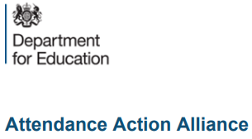
The work of the Attendance Action Alliance brought to bear across Redcar & Cleveland including AAA’s back-to-school campaign. Topics have included communication with parents, SEND, the need for wider engagement in school beyond just the basic curriculum, the importance of mental health support teams, a strong pastoral support offer in schools, the use of reasonable adjustments and harvesting successful policing interventions in this domain.

DfE is reliant on other areas ‘to turn the dial’ on the underlying causes of absence such as education recovery (attainment), and the Care and SEND Reviews (complex need) – reflecting that the attendance programme is a cross-cutting one.

Children’s Social Care (CSC) and SEND Implementation Plans – including a new model for Family Help (including Family Hubs), a national framework for CSC, updated statutory guidance and national standards.

Education recovery activity helping pupils feel comfortable and confident to return to school and making up for lots learning

Regional support – attendance support provided through Education Priority Areas and the Trust and School Improvement Offer plus support and challenge of Las and trusts from Regions Group staff

Targeted support

£200 million investment: offering intensive support to the most vulnerable through the Supporting Families and reforming Family Help (Family Hubs in 87 Las, CSC Pathfinders in 12 local areas reforming Family Help)

£16.6 million pa Virtual Schools Head programme expansion

Supporting those at risk in serious violence hotspots with the SAFE and AP Taskforces

Building attendance metrics into the SEND and AP inclusion dashboard; also a new CiN attendance indicator in the CSC national framework

Wider measures

Programmes like breakfast clubs and the holiday activities and food programme stand to particularly benefit disadvantaged children and help to support their attendance

£21 million in training more educational psychologists

High need budget to £10.1bn in 2023/24 up 50% on 2019/20

Additional free schools

Senior mental health lead training

This is being offered to all state schools and colleges. Further roll out of Mental Health Support Teams and the publication of new guidance on how to support attendance where mental health is a barrier

The above are just extracts from known DfE investments that respond to the multi-faceted drivers of absence – owing to health needs / service pressures, mental health / behaviour and economic, family functioning challenges.
Targeted support for vulnerable young people in serious violence hotspots - GOV.UK (www.gov.uk)  Extending the Alternative Provision Specialist Taskforce Pilot (APST) until March 2025 to learn lessons for the future | SAFE (‘Support, Attend, Fulfil, Exceed’)  taskforces | 




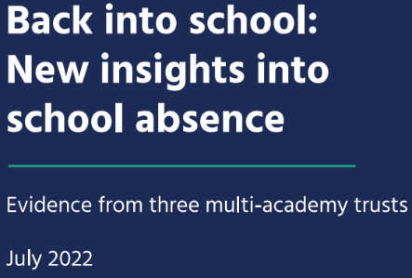

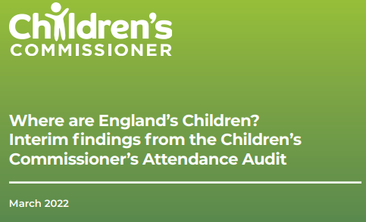

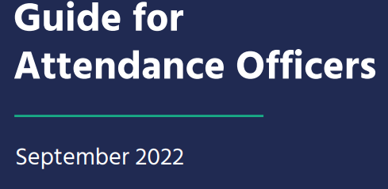

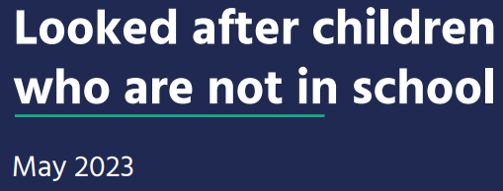

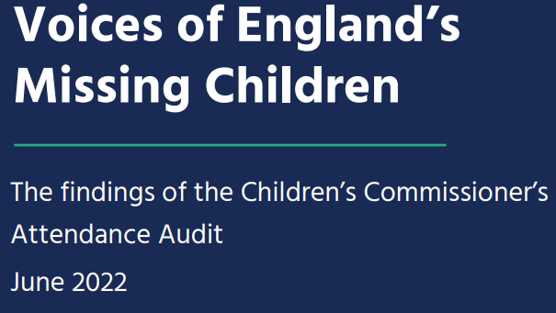

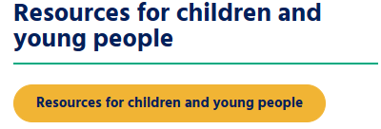


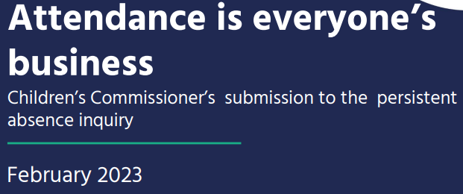

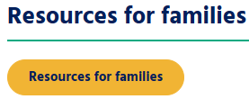
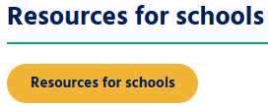

Back into School | Children's Commissioner for England (childrenscommissioner.gov.uk)

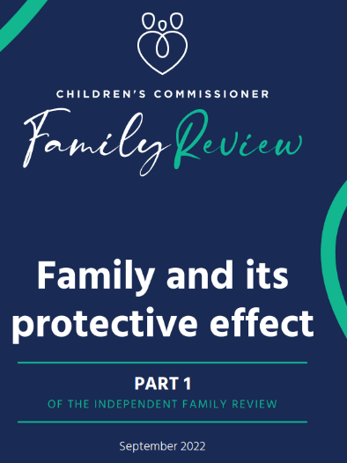
‘Invisible’ children in care are missing school every day, unique new data shows – May 2023
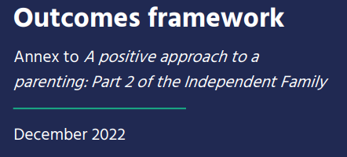
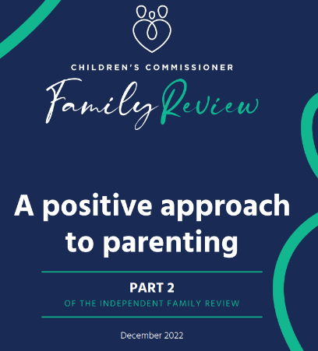

What could be done better or differently in school / college to support good attendance?
Listen to young people  Listen, care and offer compassion in all dealings with a child | Get back to a human conversation with a parent when they phone in to report an attendance issue rather than an answer machine. This misses the opportunity to listen and understand the wider context for an absence.
Consider having a more robust plan to support child/ren transitioning from primary to secondary school | Encourage all schools to take up the offer to do poverty proofing to improve whole school approaches in this regard
Making it easier for parents to more easily navigate who's who in school (there can be multiple contacts) to improve the feeling of talking to someone who listens, cares, understands and can support or take action | Remove anything (policy-wise / culturally / behaviourally) that creates stigma for a child and gives them this reason to choose not to attend
Improve communication between school team members who can sometimes be in contact with the same parent without knowing what the other staff member has been in touch with them about at the same time | Consider reviewing the proportionality of consequences issued in schools; lived experience insight suggests these are felt to be disproportionate by some parents that have commented on this issue
Make school / college a place where a child wants to be which means creating a place where they feel respected, valued, treated as individuals and feel they belong and not feeling like 'they want rid of us', 'I don’t fit' or 'I'm treated like a robot. | If a child has been absent offer the 'fresh start' when they come back as the feeling is that it doesn’t feel like it for the child - they feel like they are still being judged or punished for their previous lack of attendance/absence
Having an individual plan that is shared, understood and supported around the CYP struggling with attendance | There is very little restorative practice in school, first contact can be negative (e.g., about wearing trainers) – this could be better
Would be good if all schools took up the offer of 'Poverty Proofing' to be more sensitive to CYP needs that could then contribute to their attendance/ behaviours | Create conditions and behaviours to support a child if they are having a bad day e.g., check-ins, more interactive ways of the child rating their lessons and expressing their emotions about things rather than them building up.
Ensure that schools / colleges / educational settings are all SAFE spaces | Arranging peer support where a CYP is allocated a peer if anxiety is identified
What else can Year 6 teachers do to prepare CYP for transition to secondary school? | Pastoral support in secondary schools are 'firefighting' most of the time, unlike the nurturing way in primary school.
Early and earlier intervention to prevent attendance issues escalating | These ideas were captured in May 2023 at Tuned In as part of the ‘lived experience’ strand of this Project where c20 delegates from across the system
What could be done better or differently in communities to support good attendance?
Provide more opportunities for young people to understand the benefit of completing school by intersecting with companies who may be future employers so they can see what opportunities they could potentially embrace later in life | Need to communicate the frustrations of children falling between services and or waiting for services to support them and find ways of breaking 'vicious cycles' with community support - not just the services.
Resource more community capacity building roles because who best to engage parents in an area than someone from that area and who also has the skills to help navigate 'the system' | Having an individual plan that is shared, understood and supported around the CYP struggling with attendance
Put people with lived experience in the driving seat so they can lead the conversations, be listened to, champion issues that matter to them - adults / parents and children and young people. This is needed for so many aspects of making change in Redcar & Cleveland. Can we learn from experiences described by Red Balloons and Starfish and bring some of that into our communities? | Exploring and perhaps investing more in the role that community centres do, or could, play in providing non-judgemental, safe spaces - something that has been described as generally lacking in some of the school environments that children would appreciate

What could be done better or differently at home to support good attendance?
Communication between parents and school / college (two-way improvements needed) | Inspire parents
Ask parents what support they need and understand the wider challenges and inequalities they are dealing with (e.g., poverty, food insecurity, inability to access specific Apps for school related communication) | Giving parents support to encourage better routines and boundaries e.g., motivational interviewing techniques; and sleep hygiene (no mobile phones from bedtime)
Supporting parents to change the way they put their own (negative) attitudes about school across to their chid/ren | Having an individual plan that is shared, understood and supported around the CYP struggling with attendance

Other ideas suggested by contributors to the Project over the course of 2023
- Re-orienting the existing Attendance Network to be more strategic and sharing good practice
- Collecting SWOT analysis of attendance practice from all Attendance Network participants by RCBC’s Inclusion team leading to even better conversations and support around the child, family and school. Conversations could track changes and ‘maturity’ in attendance practice over time.
- Applying recommendations from the National Education Select Committee Inquiry into disadvantage and persistent absence at a local, contextualised level
- Explore how we communicate what we already have to offer around careers education, information, advice and guidance to latch on to a young person’s interests and motivations
- Explore ways of involving children (with higher risk factors of non-attendance) to access alternative, more motivational ways of learning e.g. the local cinema project build provided a focal point of interest to young people.

EARLY INTERVENTION
- Push the early intervention work first rather than the prosecution aspect which should be a tool of last resort when exhausted everything else.
- Work with the school to identify if every possibility has been exhausted before legal action kicks in
RELATIONAL APPROACHES
- Create a system that gives time to enable a deeper understanding of needs and relationships. Understanding a family and child’s needs and formulating a clear response to meet those needs and value that relationship
- Tap into skills from other sectors e.g. school nurse, mental health support as part of the relational approach
- Explore and seek to resource more strengths-based mentors for young people in their lives – ‘an absolutely valuable asset’ to work around the young person, their needs, their difficulties and their talents
INDIVIDUALISED SUPPORT ‘DONE THE RIGHT WAY’
- In schools find the money to employ the right people to do the right jobs which means conversations with parents, going out to homes, meeting in a neutral venue if necessary. This is time and money intensive; we know they make a difference, but budget constraints mean schools have less money again to do this as well as they might like.
- Developing the skills for school staff….it’s a skilful job to talk to a parent…..having the skillset and training
TRUSTED PERSON IN EACH YOUNG PERSON’S LIFE
- If we want to make attendance everyone’s business there is always a trusted person in the stories….maybe not in the school, but elsewhere in their lives. We have to create and celebrate these positive role models and tap into their ability to motivate each young person not able to or choosing to attend well.
COMMUNICATION – a theme to explore further
- “Better communication within the authority and partnering teams - should be more consistent approach across the authority and clear messages.”
Learning from lived experience – solutions need to be mindful of these ingredients.
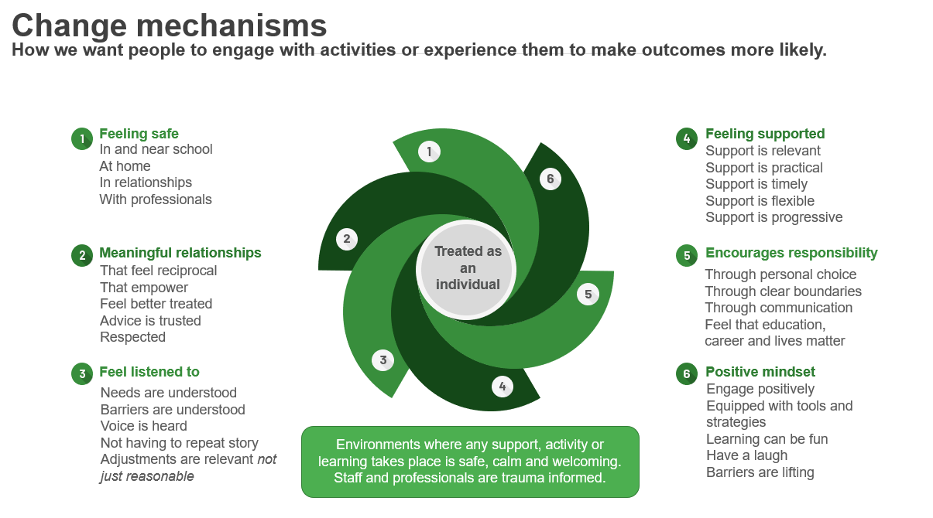
Wider solutions across the UK from the desk research as part of this project
Theme | Suggested interventions
Early intervention | - Family engagement approaches to address underlying issues  - Mentoring programmes to provide individualised support targeted particularly for at-risk students  - Counselling services to address emotional and psychological challenges
Positive school climate | - Inclusive environment creating a welcoming and inclusive atmosphere to reduce social anxiety  - Anti-Bullying Initiatives: Implement strategies to prevent and address bullying  - Student Engagement: Provide interesting and relevant curriculum to engage students  - Flexible learning options for students with health-related absenteeism  - Student-led initiatives to improve school climate
Personalised support | - Individualised Education Plans (IEPs): Develop tailored education plans for students with specific needs  - Flexible Learning: Provide options like online learning for students who struggle with traditional settings  - Peer Support: Create peer mentorship programmes to enhance social connections  - Outreach programmes for students facing socio-economic challenges
Collaboration | - Interagency Collaboration: Work with social services, mental health agencies, and community organisations  - Collaboration with local health services for students with chronic illnesses  - Collaboration with community organisations for holistic support Teacher-Parent Collaboration: Regular communication between teachers and parents to address concerns  - Multi-Disciplinary Teams: Form teams to address complex cases comprehensively
Skill building | - Social Skills Training: Teach students effective communication & interpersonal skills  - Emotional Regulation: Provide strategies to manage emotions and stress  - Truancy prevention workshops
Systems change working examples | Leeds  - Development of local attendance strategy involving multi-agency collaboration  - Training for school staff and families on attendance issues  - Community engagement and awareness campaigns
Manchester
- Multi-tiered system of support for attendance, focusing on prevention, early intervention, and intensive support
- Integrated information sharing among agencies
- Data-driven decision-making for targeted interventions
Bristol
- Creation of attendance improvement boards with representatives from multiple sectors
- Development of tailored support plans for at-risk students
- Holistic family support through partnership working
London
- Establishment of multi-agency attendance teams to address complex cases
- School-based health clinics for easy access to medical care
- Mentoring and peer support programs to engage students
Sheffield
- Implementation of 'Challenge Days' where agencies collaborate to address attendance barriers
- Student-led campaigns to promote positive school climate and attendance
- Inclusive curriculum planning to engage all students
Newcastle
- Coordinated approach to address absenteeism involving multi-agency teams
- Provision of alternative education for students with prolonged absences
- Personalised learning plans for students with health conditions
Birmingham
- Implementation of a city-wide approach to tackle attendance issues
- Intensive support for students with chronic absenteeism through mentorship
- Linking youth services with schools to enhance engagement
Recent suggestions from the Theory of Change Working Group
Place-based pilot(s)

Create the conditions for systems-working but within one geographical place within the Borough to learn how to reduce the risk and prevalence of persistent and severe absence between 2024 and 2026 with view to sharing best practice during that period and transferring that know-how and solutions to the wider Borough beyond 2026. This would mean getting all system partners working ‘as one’ in the selected place pilot area and maximising each other’s resources, assets and strengths to provide child-centred solutions and whole family working in ways that impact attendance behaviours.

This idea was received favourably when mooted at the 2nd ToC workshop in November 2023. Should we build on this idea together for 2024 and make it happen?

Engagement  Invest in the arts, PE, cultural capital and on bringing the joy back to schools as places of education in the broadest sense. If this can’t be done as part of the daily curriculum, how can we add it to highly valued and high quality before and after school clubs – things that children really want to do and that enable children and young people to make functional friendships and to ‘find their tribe’, as well as learning to succeed and fail in low-risk environments.  Enablers and barriers  - Government funded wrap around care programme – aimed at childcare not clubs but could create capacity  - Schools are already overworked/underfunded – may need 3rd sector? | Evidence sources were kindly supplied by the contributor including the EEF Toolkit (n.b. focused on how to improve attainment outcomes rather than attendance outcomes)
Data and intelligence

Peer review October 2023 – we don’t use data and intelligence well enough to make well informed strategic decisions.
Solution
We need to use data better to know/be able to:
- Trends and patterns over time
- Live data e.g. Who is PA/SA
- What the patterns are to these absences – per pupil, per cohort, per school
- How to regularly benchmark ourselves against others
- Which of our initiatives are/are not working – for an individual child, group, cohort, school, area
- Produce data informed strategy rather than scatter gun initiatives.

Enablers and barriers
- Wonde – the free DfE capture tool for attendance can enable this and is very easy for schools to engage with. Are we using it effectively? Establish this before we opt for other high cost solutions
- Building trust with schools around ‘all in this together’ so they are happy to share data

Further suggestions from the ToC Group

The issue: young people feel they are “told” how to improve attendance, and they have no control over the tools/resources used.
Suggestions
- Attendance improvement posters used in schools designed by students for students
- Link the VCS sector with education further for support/mentoring/families;
- Involve employers in mentoring support
- Alumni from school working (once a week) with young people struggling around attendance (sometimes including behaviour and rising suspensions).

Peer Influence programmes e.g. EEF’s Grassroots Programme

“I am interested in learning more about Grassroots (EEF and YEF). Our nearest area is Leeds. I am not sure if our schools could get involved, they say able to travel to one of the areas. Regardless, I think it would be worth us speaking to the Team about the work they are doing. I am very interested in Peer Influence programmes. It’s still very much in the early stages, first evaluation report will not be published until 2025.”

Other suggestions were generated at the ToC workshop on the 5th of December 2023

Sources: Lancashire Educational Psychology Service, Emotionally Based School Avoidance | West Sussex Services for Schools and Brighter Futures for Children are useful sources
Attendance HUB - Northern Education Trust (100 schools signed up for the pilot which will see the sharing of strategies and resources for improving attendance) and River Tees Multi Academy Trust (rtmat.org.uk) ‘Attendance at River Tees Multi-Academy Trust (RTMAT) academies is, like safeguarding, everyone’s business.’
https://www.youtube.com/watch?v=pKee0FteBdQ
1. Voice of CYP and families 2. Mental Health 3. Poverty 4. Additional Needs & Vulnerability 5. Inequalities and access 6. Strong start in life 7. Health promotion 8. Family support 9. Childhood illness 10. Data, digital & communication
Transformational reform begins for children and young people with SEND - GOV.UK (www.gov.uk) - £70 million change programme announced 2nd March 2023
Alternative Provision Specialist Taskforces (APST) | Department for Education | Youth Endowment Fund and Targeted support for vulnerable young people in serious violence hotspots - GOV.UK (www.gov.uk). Announced by Children and Families Minister Vicky Ford 3rd September 2021
£30 million will be invested into a programme of SAFE taskforces which will be rolled out in 10 of 21 serious violence hotspots areas from early 2022. This 3-year initiative will be led by local schools to protect young people at risk of truant and from being permanently excluded. The SAFE programme will deliver targeted interventions to reduce truancy, improve behaviours, and reduce the risk of individuals failing to enter education, employment or training (NEET).
Behaviour hubs - GOV.UK (www.gov.uk) - The Behaviour Hubs programme supports school leaders by helping them to create calm, safe and supportive environments – with pupils in schools and ready to learn
Persistent absence and support for disadvantaged pupils - Committees - UK Parliament
Sources considered: Guardian Education Hub; Department of Education/Ofsted; Children Commissioner and Attendance Mentor

